[](http://www.leehansen.com/clipart/Parties/Fiesta/thumbs/maracas-th.gif)

### Mohawk High School

605 State Highway 231

Sycamore, OH 44882

419-927-6222

La Clase de Español

Noticias de la clase del Señor Parlier

**[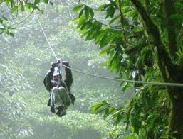](http://www.google.com/imgres?q=zip+lining+costa+rica&hl=en&biw=1366&bih=514&tbm=isch&tbnid=IuM1TWeY5QSUMM:&imgrefurl=http://www.experiencecostarica.co.uk/zip-lining.html&docid=pZGbEeEp8zctnM&w=433&h=330&ei=r6duTtztMeKRsAKfj6nBCQ&zoom=1)

*This year we will be staying in a hotel and going on several excursions and sightseeing around the country.*

*We will see a live volcano, catch some waves in the Pacific Ocean, go zip-lining through the rainforest and even go whitewater rafting. It’s going to be a great time!*

*For cost, travel dates and more information:*

*1.) Go to www.eftours.com*

*2.) Click on students/parents in the top right corner*

*3.) Go to the bottom right corner of that page under Get Started Today*

*4.) Click either check out a tour or enroll on a tour*

*5.) Enter the tour number: 1136597*

*Participants can also enroll by calling 1-800-665-5364.*

*Remember to attend the meeting on Tuesday, September 27th at 7:00 pm in the Spanish room.*

[](http://justolamas.com/reservation_form.php)

Justo Lamas will be at Mohawk on Friday, December 2nd to put on a concert for the students in Spanish and other schools around the area. Justo has been to our school the last few years. This will be his final tour.

Tickets are on sale now for $13.

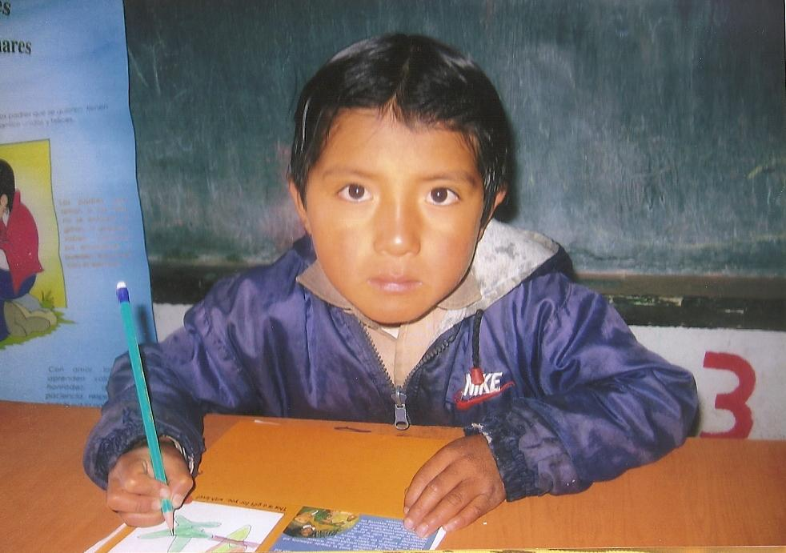

Franklin is a little boy from Ecuador. Spanish Club has been sponsoring Franklin since he was a baby. Now, he is 8 years old and doing well thanks to the students at Mohawk. We have been able to provide Franklin with medical attention, school supplies, food, clothing and more.



Número Mágico

1. Piensa en un número.
2. Súmale diez y nueve.
3. Súmale doce.
4. Réstale seis.
5. Réstale siete.
6. Súmale veinte y cinco.
7. Réstale el número que pensaste al principio.
8. Para ver la respuesta, vea página dos . . .

*Remember to send in Christmas Boxes for the children in Mexico*

Bonus Questions:

Answer these questions and turn them in to Señor Parlier by Monday, September 19th for 10 bonus points!

1. What is Selena Gomez’s birthday?
2. How many years has Justo Lamas be performing concerts to schools around the United States?
3. On the Tour Summary page, what is the name of our trip?
4. What is the official currency of Ecuador?
5. How many craters are there on the Poás volcano in Costa Rica?
6. How high is the “La Fortuna” waterfall in Costa Rica? As a perspective, how high is Niagara falls?
7. What television show did Selena Gomez first appear on?
8. What are the names of Justo’s two children?
9. What is our scheduled departure date for our trip to Costa Rica?
10. Figure out this puzzle:

Hispanic Heritage Month

September 15th – October 15th

[](http://www.google.com/imgres?q=selena+gomez&hl=en&sa=X&rls=com.microsoft:en-us:IE-Address&rlz=1I7ACGW_enUS370US370&biw=1366&bih=514&tbm=isch&prmd=ivnsuo&tbnid=O3oW7MJaEPP-PM:&imgrefurl=http://www.perfectpeople.net/photo-picture-image/131573/selena-gomez.htm&docid=gyyJJBxv-DHvVM&w=1989&h=3000&ei=1LNuTtfUOsHosQKA8p2DCg&zoom=1)Hispanic Heritage month commemorates the people of the Spanish-speaking world and their contributions. This month’s spotlight is on Selena Gomez.

Selena Gomez is famous for many things. She played the role of Alex in Wizards of Waverly Place. She has been in several movies, including Ramona and Beezus. Now, she is busy singing. One of her big hits is “Love you like a love song” among others. She is also well known because she is dating Justin Bieber.

## Good to know:

*Here are some new words to learn:*

*1. Wizard – Mago*

*2. Tour – Gira*

*3. Song - Canción*

*4. Ticket - Boleto*

*5. Rainforest - Selva*

*6. Trip – Viaje*

*7. Cow – Vaca*

*8. Singer – Cantante*

*9. Christmas – Navidad*

*10. Waves - Olas*



La respuesta correcta es . . .

(cuarenta y tres)

